NAME: K Yamini
REG NO: 192572181

Write a Python program to solve the 8–Queen problem using Backtracking.
Aim:
To place 8 queens on a chessboard such that no two queens attack each other.
Algorithm:
- Start with an empty 8×8 chessboard.
- Place a queen in the first column.
- Check if the queen placement is safe:
No queen in the same row
No queen in the same column
No queen in diagonal positions
- If safe, move to the next column.
- Repeat the process for all columns.
- If placing a queen leads to conflict:
Backtrack (remove queen)
Try next row
- Continue until all 8 queens are placed.
- Print the final board configuration.
Python Code:
# Size of board
N = 8

# Function to print board
def print_board(board):
for row in board:
print(row)
print()
# Check if position is safe
def is_safe(board, row, col):
# Check row on left side
for i in range(col):
if board[row][i] == 1:
return False
# Check upper diagonal
i, j = row, col
while i >= 0 and j >= 0:
if board[i][j] == 1:
return False
i -= 1
j -= 1
# Check lower diagonal
i, j = row, col
while i < N and j >= 0:
if board[i][j] == 1:
return False
i += 1
j -= 1
return True
# Solve using backtracking
def solve_queen(board, col):
if col >= N:
return True
for i in range(N):
if is_safe(board, i, col):
board[i][col] = 1
if solve_queen(board, col + 1):
return True
# Backtrack
board[i][col] = 0
return False
# Initialize board
board = [[0]*N for _ in range(N)]
# Solve
if solve_queen(board, 0):
print("Solution Found:\n")
step = 1
for row in board:
print("Row", step, ":", row)
step += 1
print("\nExplanation:")
print("# 1 represents Queen placement")
print("# 0 represents empty space")
else:
print("No solution exists")
Input:
Board size = 8
Output :
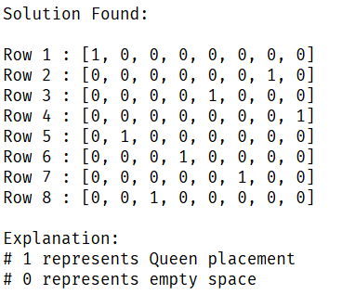
Result:
The 8–Queen problem is solved successfully using backtracking, and a valid arrangement of queens is obtained.

